**Assignment Submission Template**

**1. Student Registration Information**

* **Full Name**: [Student's Full Name]
* **Student ID**: [Student's SIS ID Number]
* **Course Name**: [Course Name]
* **Instructor Name**: [Dr Ahsan Abdullah]
* **Date of Submission (mm-dd-yyy)**: [Submission Date]

**1. Assignment Overview (0.5 Points)**

* Provide a **clear title** for the assignment.
* Include a concise **objective statement (1–2 sentences)** that describes what the assignment aims to accomplish.

**✅ Requirement:**

* Title is present



* Objective clearly stated in 1–2 sentences



**2. Code Implementation (2.0 Points)**

* Submit **fully functional code** that meets all assignment requirements.
* Ensure code is properly **formatted and indented**.
* Include **clear, helpful comments** explaining key sections and logic.

**✅ Requirement:**

* Code is complete and executable



* Proper indentation and formatting used



* Comments explain major components and logic



**3. Results Screenshot(s) (1.0 Point)**

* Provide **one or more screenshots** showing the program in action.
* Each screenshot should include a **brief description** of what it displays.

**✅ Requirement:**

* Screenshot(s) showing execution/output provided



* Descriptions accompany screenshots for clarity



**4. Data or Output Results (2.0 Points)**

* Include **generated output or data results** from the program.
* Format data clearly (e.g., table, plain text, CSV).

**✅ Requirement:**

* Complete and relevant output included



* Output is clearly formatted and readable



**5. Analysis of Results (1.5 Points)**

* Write an **analysis of the results**, reflecting on:
  + Correctness of the output
  + Any issues encountered
  + Insights or learning from the results

**✅ Requirement:**

* Explanation of results



* Discussion of correctness and any limitations



* Personal reflections or insights



**6. Conclusion (1.0 Point)**

* Provide a **summary** of what was accomplished in the assignment.
* Mention any **improvements made**, lessons learned, or **ideas for future work**.

**✅ Requirement:**

* Clear summary of outcomes



* Reflection on learning or future steps



**7. Key Reflective Questions (1.5 Points)**

* Answer all **three provided reflective questions**.
* Responses should show thoughtful engagement and originality.

**1. Explain a specific part of your code that was most challenging to implement. Why was it difficult, and how did you resolve it?**

**2. If you had to modify your code to handle an additional feature (e.g., session expiration message or logging login attempts), where would you make the changes and why?**

**3. Describe a mistake you made during development and what you learned from it.**

**✅ Requirement:**

* All reflective questions answered



* Answers are specific, clear, and thoughtful



**8. Additional Comments – Bonus (0.5 Points) *(Optional)***

* Include any **additional insights, reflections, or feedback** beyond the required components.
* May include improvement suggestions, unexpected challenges, or creative ideas.

**✅ Optional Submission:**

* Additional comments or reflections included (for bonus consideration)



**Student Registration Information**

* **Full Name**: Abbie Grooms
* **Student ID**: 200976603
* **Course Name**: Web Application Programming
* **Instructor Name**: [Dr Ahsan Abdullah]
* **Date of Submission (mm-dd-yyy)**: June 14, 2025

1. Overview:
   1. Title: Multi-Page Website with Nested Navigation: Astronomy, Animals, & Cooking
   2. Objective: The goal of the assignment is to design and implement a responsive multi-page website that uses nested menu navigation to organize content into subjects and topics, with working navigation links and deployment on public hosting platform.
   3. Link: [Nested Menu Website](https://akg-create.github.io/nestedwebsite/index.html)
2. Code: All code is found within the zip file.
3. Results:

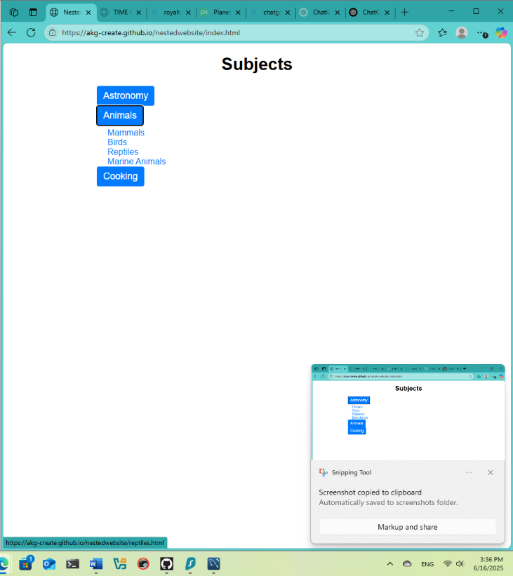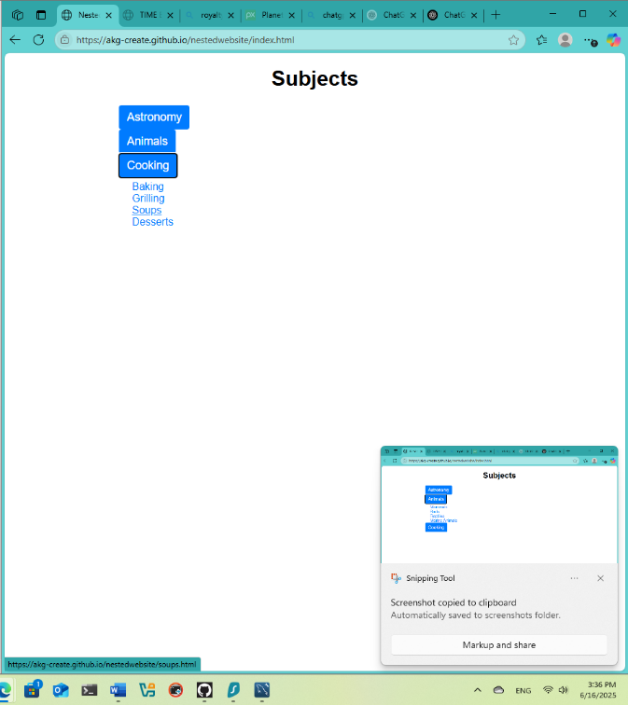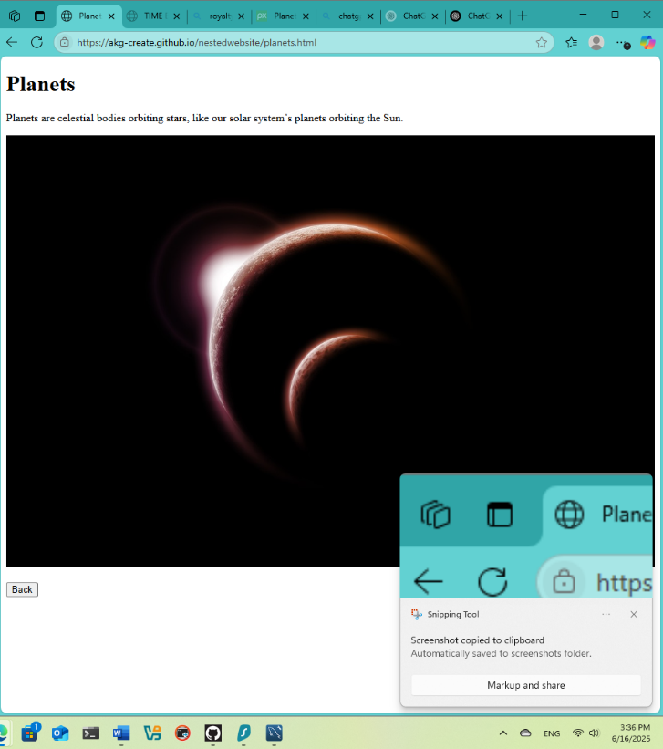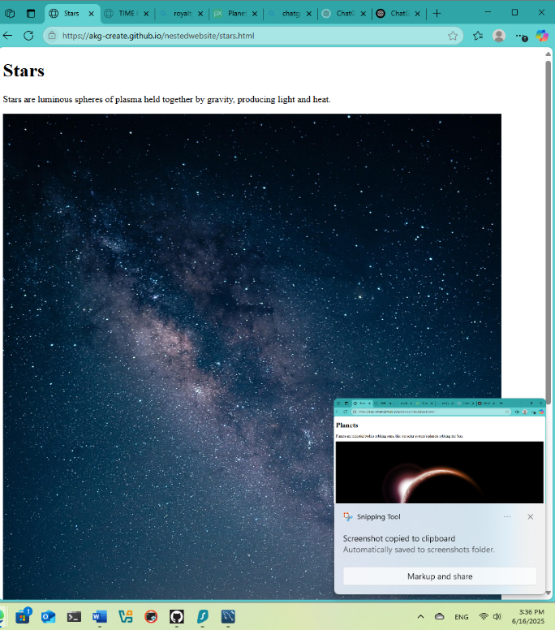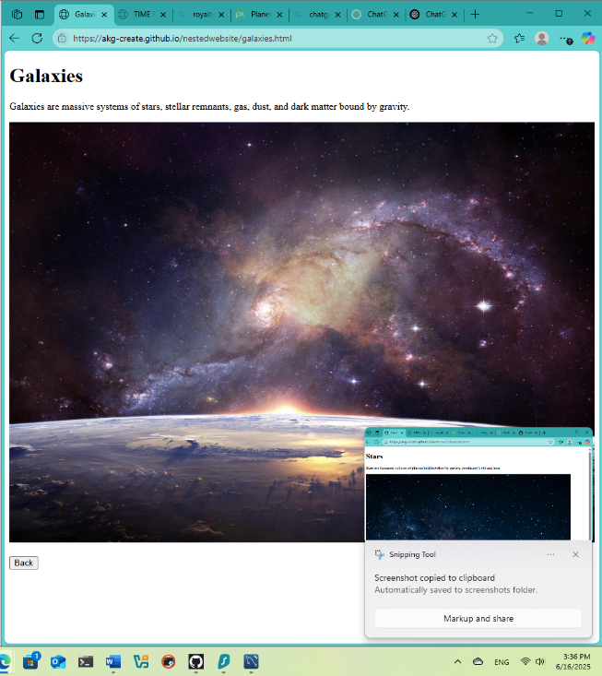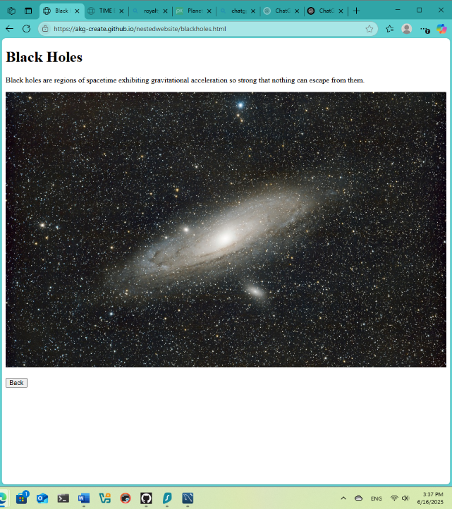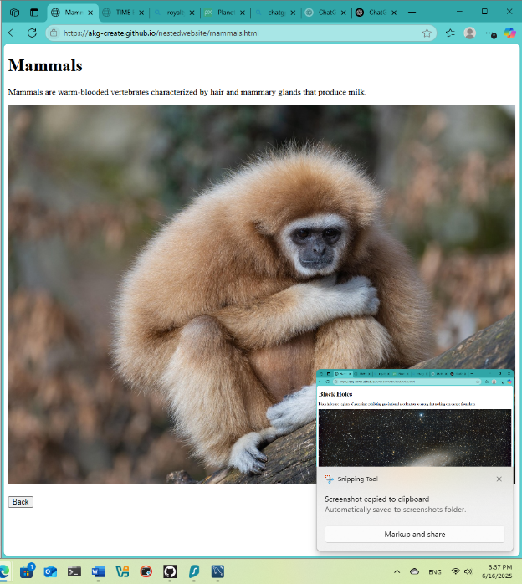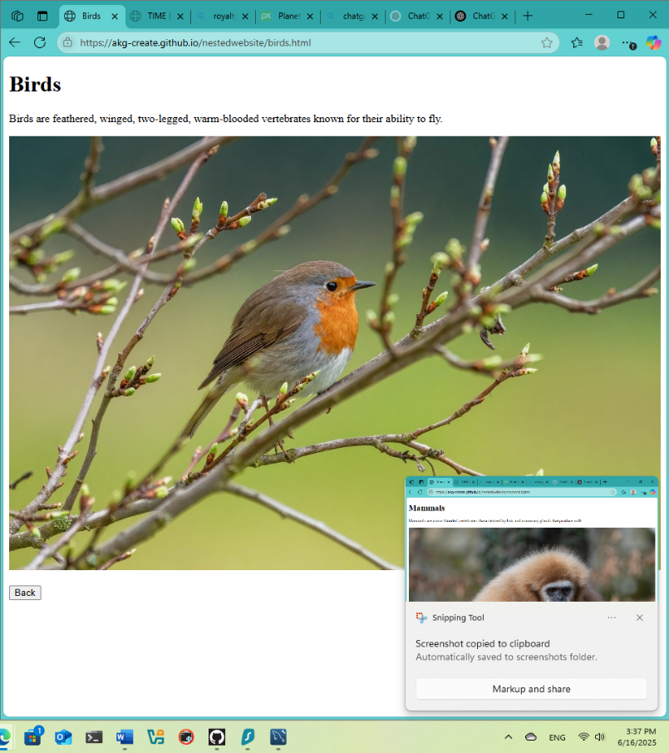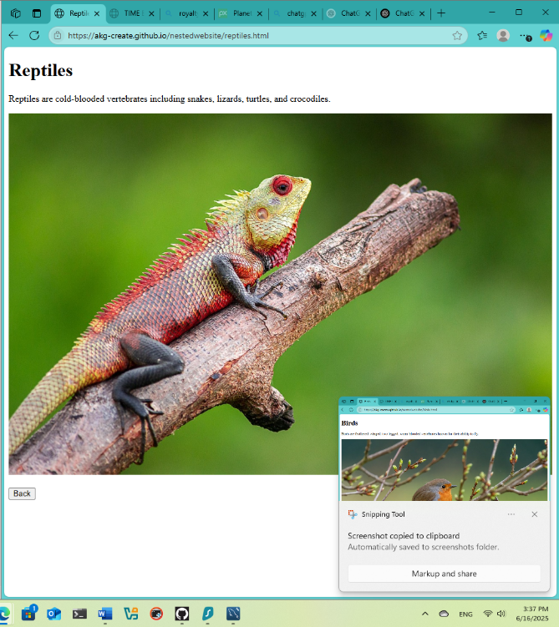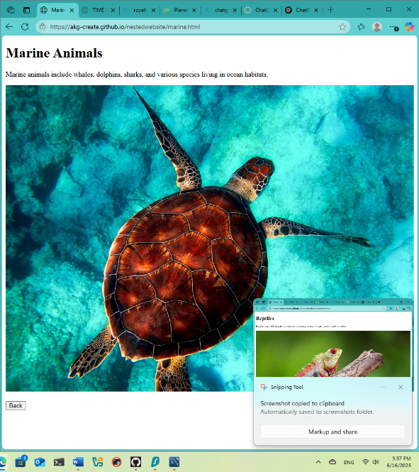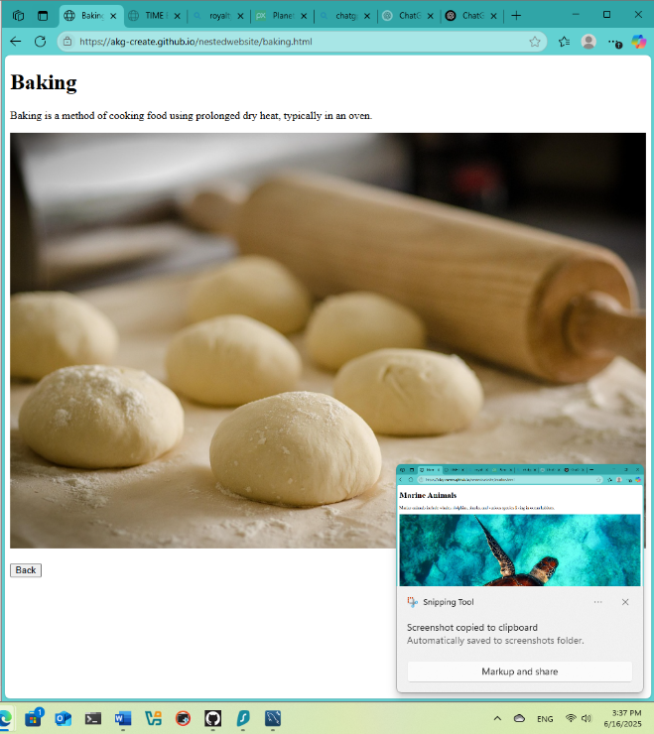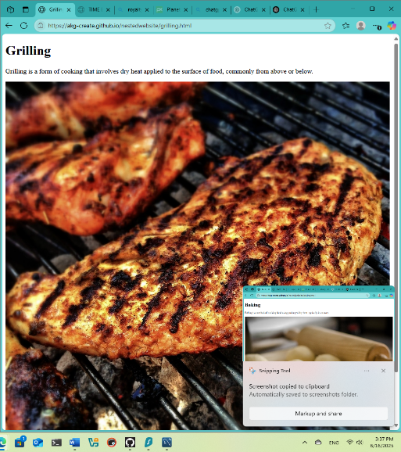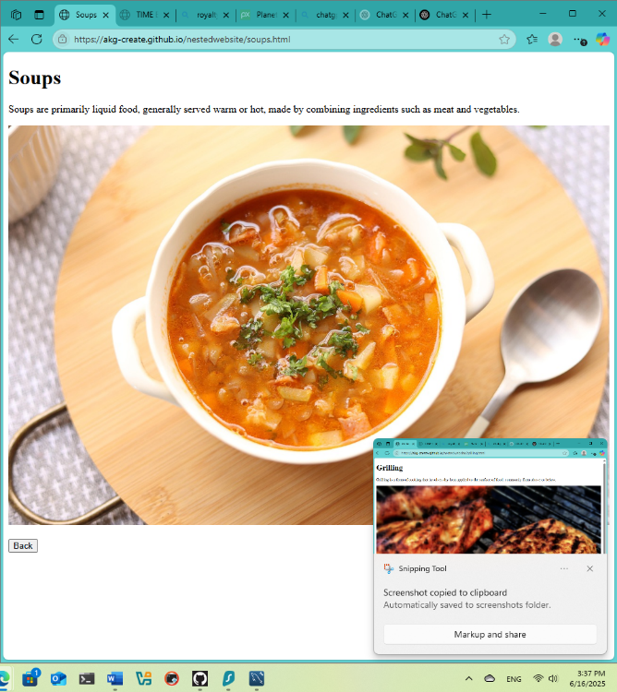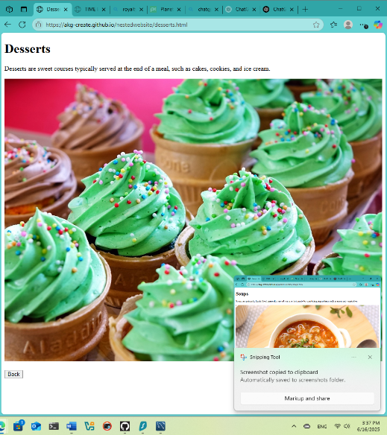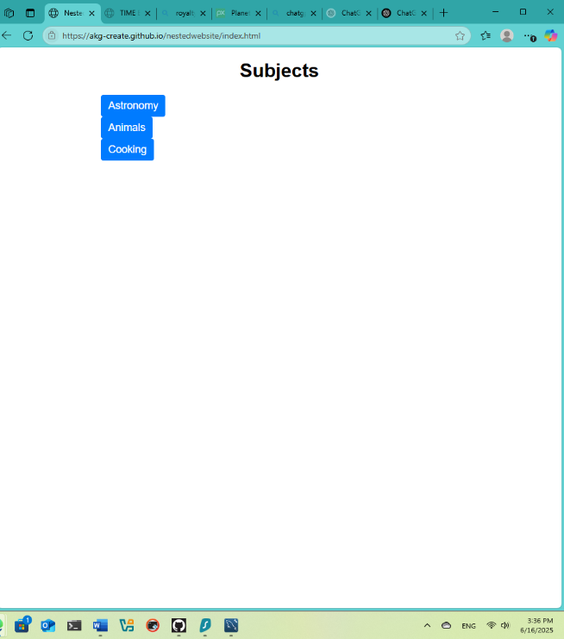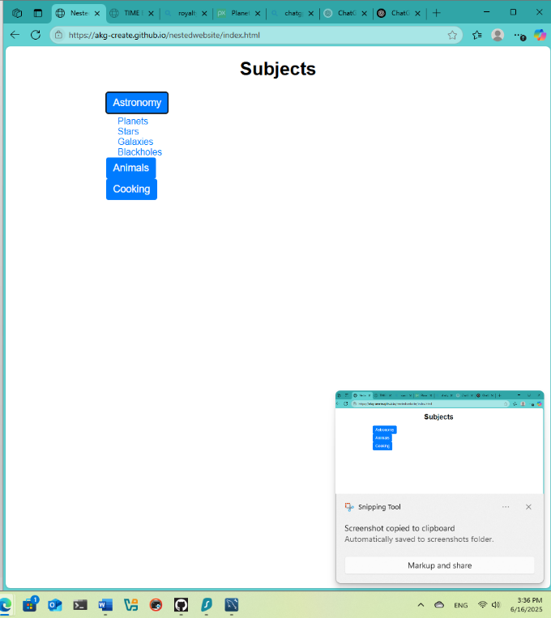

1. Data Results:
   1. Output consists of 13 HTML pages in total:
      1. Homepage( index.html)
      2. 12 topic pages (4 each for Astronomy, Animals, and Cooking)
   2. All topic pages follow consistent structure:
      1. Each includes a heading, descriptive paragraph, an image and navigation button.
   3. Navigation button is fully functional:
      1. Subject buttons on homepage display relevant topic lists.
      2. When each topic is clicked it takes user to relevant topic page.
      3. Each topic page consists of a working “Back” button to return to homepage.
   4. Website design and navigation work on both desktop and mobile devices.
2. Analysis of Results:
   1. Output was correct. All pages loaded properly and navigation flows logically.
   2. Minor issue encountered was related to JavaScript not resetting the homepage view, which was resolved by explicitly hiding all submenus on page load.
   3. Learned how to manipulate the DOM dynamically and apply responsive design principles.
3. Conclusion:
   1. The assignment demonstrated the ability to build and organize a structured, multi-page website using HTML, CSS and JavaScript.
   2. Learned the effective use of nested menus and JavaScript DOM manipulation. Future work could add animation, search or local storage for state saving.
4. Reflective Questions:
   1. The most challenging part was ensuring that clicking the “Back” button reset the homepage to show only the top-level subjects. I resolved this be writing a function that hides all topic menus and attaching it to the Back buttons event listener.
   2. I would like to add a session expiration alert, using setTimeout() to display a message if no interaction is detected after a period.
   3. Initially, I forgot to set display: none for topic menus, so all topics appeared on page load. I learned the importance of initializing page state using JavaScript to ensure clean UI behavior.